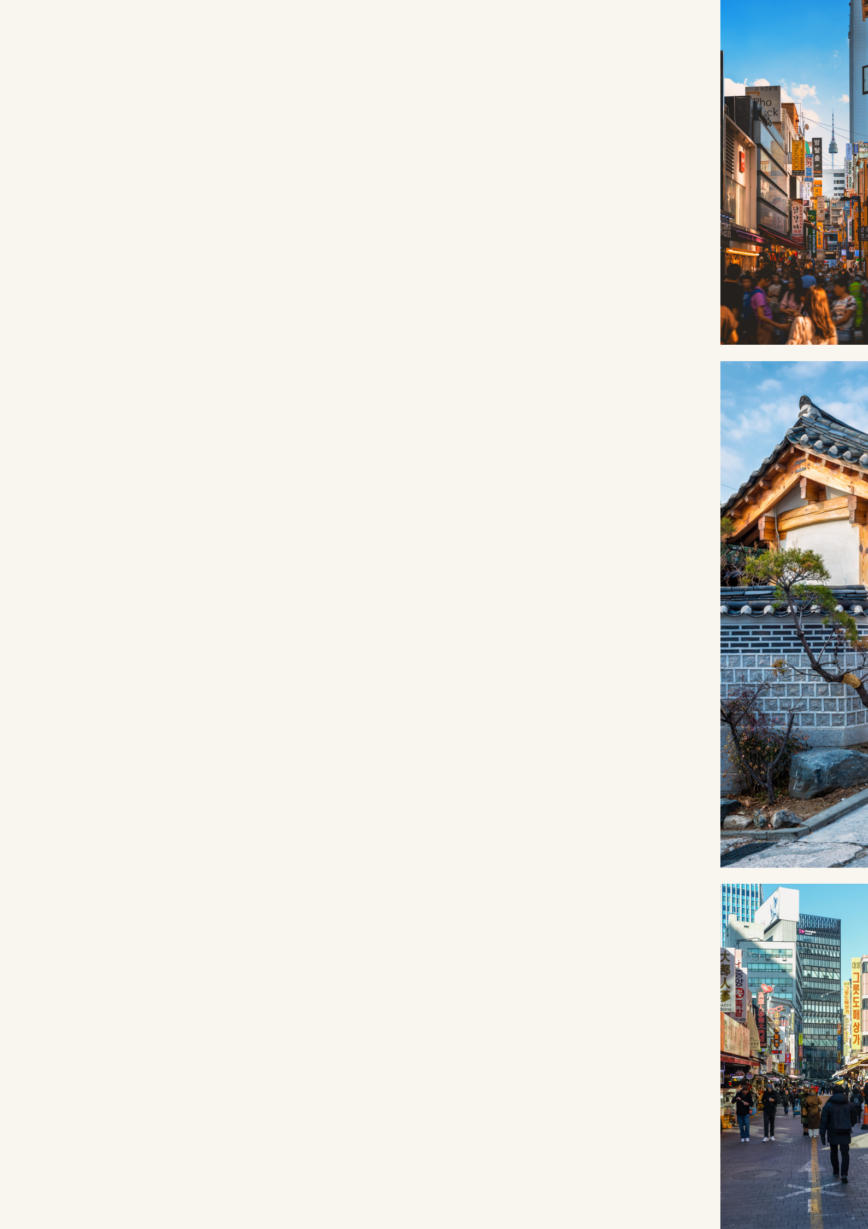
TRAVEL Itinerary

D A Y EXPLORE MYEONGDONG 0 1

Morning: Afternoon:

Arrive at Incheon Check into your hotel.

International Airport, And start exploring

take the train to Seoul. Myeongdong.

Evening: Night:

Enjoy street food in Visit N Seoul Tower for

Myeongdong. stunning night views

of the city.

D A Y JOSEON PALACE & HANOK VILLAGE 0 2

Morning: Afternoon:

Visit Gyeongbokgung Rent a hanbok & take

Palace & start pictures in Bukchon

exploring. Hanok Village.

Evening: Night:

Explore Insadong, an Enjoy the Nanta show,

arts & culture. a unique non-verbal

comedy performance.

D A Y GANGNAM & NAMDAEMUN MARKET 0 3

Morning: Afternoon:

Visit Gangnam, a trendy district known for its upscale shopping.

Shop at COEX Mall,

the largest shopping

mall in South Korea.

Evening: Night:

Explore Namdaemun Try street food at

Market. Namdaemun Market.

